**Performance Test Results**

**Final Report**

**Summary**

Performance testing was conducted on <appname> Application for the purposes of determining the baseline performance of the application. Testing was done with an open source load testing tool JMeter.

The final results shows the test meeting the goals established in the <appname> strategydocument.  However, the results also show no dramatic decrease in performance as more users are added to the test.

As a result, 50 concurrent users perform almost as well as 15 concurrent users, given the final tests that were run.

# Test Results Analysis

When performance testing began, the results were not satisfying.  The environment needed tuning.  After we had finished tuning the environment, we were able to start getting all the tests to succeed (no errors reported by the testing tool).

Then we started to get results.

A total of 17 transactions was part of one user’s interaction with the application. During the final phase of testing, we completed a total of 4 tests, 3 rounds of concurrency and one round of Endurance test.

Below is the Application response time for various user load.

** The results shown below are obtained before fixing the bottleneck of the application.

|  |  |  |  |  |
| --- | --- | --- | --- | --- |
| **Transactions Names** | **Average Response Time 1 User** | **Average Response time 15 users** | **Average Response Time 50 users** | **Expected SLA Response Times(Seconds)** |
| Landing page | 3.43 | 6.51 | 46.388 | N/A |
| Login by entering MFA code | 1.678 | 3.40 | 22.766 | 4 |
| Pipeline loading with filter | 0.078 | 0.23 | 1.246 | 10 |
| Quick Search | 2.758 | 3.40 | 13.257 | 10 |
| Appraisal Page | 0.375 | 0.68 | 4.178 | N/A |
| Submission of Appraisal Request | 0.455 | 1.38 | 2.883 | 10 |
| Product and pricing page | 0.265 | 3.36 | 11.298 | N/A |
| Run product and pricing | 2.722 | 6.78 | 14.509 | 10 |
| View Conditions | 0.248 | 1.09 | 4.291 | 10 |
| Lock Details Page | 0.114 | 0.93 | 3.538 | N/A |
| Request Extension Lock | 4.732 | 3.31 | 8.466 | 4 |
| Request Change Lock | 4.923 | 2.95 | 9.587 | 4 |
| Request Relock | 6.271 | 2.27 | 13.232 | 4 |
| Register Loan page | 3.187 | 1.98 | 13.192 | N/A |
| Upload Documents | 78.866 | 71.27 | 171.899 | 4 |
| Loan submission | 1.301 | 1.28 | 3.466 | 10 |
| Logout | 0.469 | 0.38 | 1.261 | N/A |

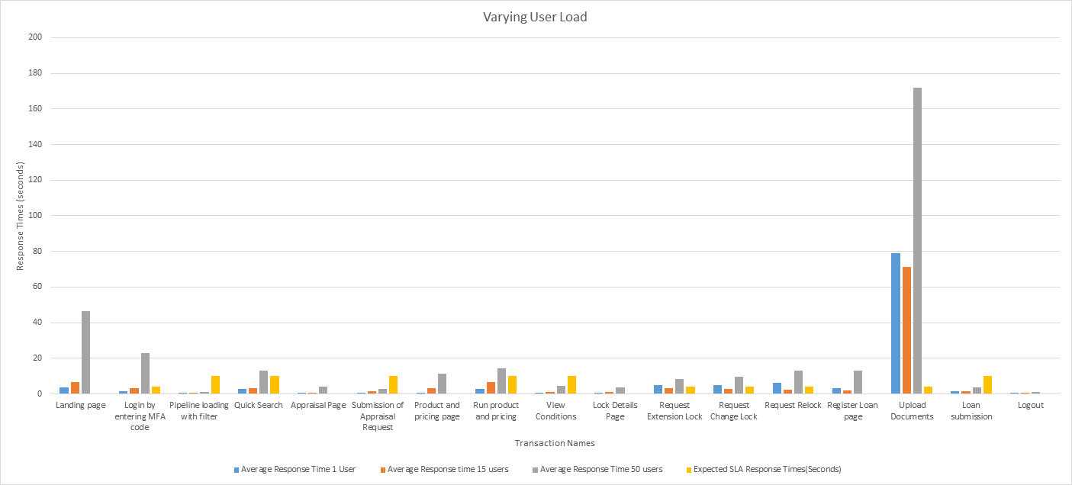

In the Initial two rounds of load test, some of the transactions did not meet the required SLA. After thorough analysis, the **bandwidth provided to the system happened to be the bottleneck which was then resolved,**

**And the 3rd load test** had all the transactions conforming to the SLA mentioned below.

|  |  |  |  |  |
| --- | --- | --- | --- | --- |
| **Transaction Names** | **Average Response Time Round1(seconds)** | **Average Response Time Round2 (seconds)** | **Average Response Time Round3 (seconds)** | **Expected SLA Response Times(Seconds)** |
| Landing page | 42.415 | 46.388 | 0.989 | N/A |
| Login by entering MFA code | 18.359 | 22.766 | 1.788 | 4 |
| Pipeline loading with filter | 1.083 | 1.246 | 0.127 | 10 |
| Quick Search | 18.861 | 13.257 | 1.815 | 10 |
| Appraisal Page | 3.38 | 4.178 | 0.188 | N/A |
| Submission of Appraisal Request | 2.776 | 2.883 | 0.572 | 10 |
| Product and pricing page | 10.014 | 11.298 | 0.457 | N/A |
| Run product and pricing | 12.814 | 14.509 | 3.458 | 10 |
| View Conditions | 3.624 | 4.291 | 0.417 | 10 |
| Lock Details Page | 3.279 | 3.538 | 0.066 | N/A |
| Request Extension Lock | 14.623 | 8.466 | 1.739 | 4 |
| Request Change Lock | 14.877 | 9.587 | 1.75 | 4 |
| Request Relock | 23.491 | 13.232 | 3.423 | 4 |
| Register Loan page | 11.1 | 13.192 | 0.792 | N/A |
| Upload Documents | 147.11 | 171.899 | 0.783 | 4 |
| Loan submission | 3.04 | 3.466 | 0.664 | 10 |
| Logout | 1.082 | 1.261 | 0.051 | N/A |

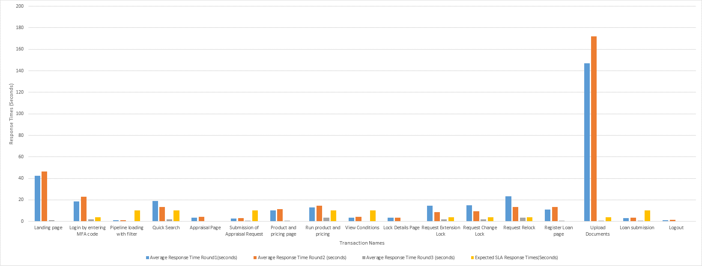

The Endurance test was performed which is mainly to test the system with a significant load extended over a significant period of time, to discover how the system behaves under sustained use, was carried out by imposing a load

of 30 users active for a period of 6 hrs. The system did not report any major failures. All transactions were conforming to the SLA.

|  |  |
| --- | --- |
| **Transaction Names** | **Average Response Time (seconds)** |
| Landing page | 0.779 |
| Login by entering MFA code | 1.063 |
| Pipeline loading with filter | 0.072 |
| Quick Search | 0.794 |
| Appraisal Page | 0.109 |
| Submission of Appraisal Request | 0.397 |
| Product and pricing page | 0.252 |
| Run product and pricing | 3.054 |
| View Conditions | 0.247 |
| Lock Details Page | 0.032 |
| Request Extension Lock | 0.751 |
| Request Change Lock | 0.696 |
| Request Relock | 0.816 |
| Register Loan page | 0.373 |
| Upload Documents | 0.485 |
| Loan submission | 0.385 |
| Logout | 0.017 |

**Conclusion**

The performance testing of <appname> application effort can certainly be thought of as a success. The testing environment was debugged, and the skills gained during that process will help in future environments for both testing and production.

The performance testing process also gained insight to the current performance profile of many areas of <appname>.